The Florence Nightingale Pledge
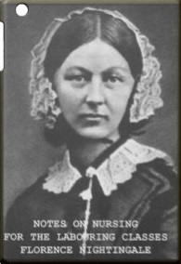
- I solemnly pledge myself before God and in presence of this assembly.
- To pass my life in purity and to practice my profession faithfully.
- I will abstain from whatever is deleterious and mischievous and will not take or knowingly administer any harmful drugs.
- I will do all in my power to maintain and elevate the standard of my profession and will hold in confidence all personal matters committed to my keeping and family affairs coming to my knowledge in the practice of my calling.
- With loyalty will I endeavor to aid the physician in his work and devote myself to the welfare of those committed to my care.”

